END OF PLACEMENT REVIEW
STUDENT PERFORMANCE AND FEEDBACK

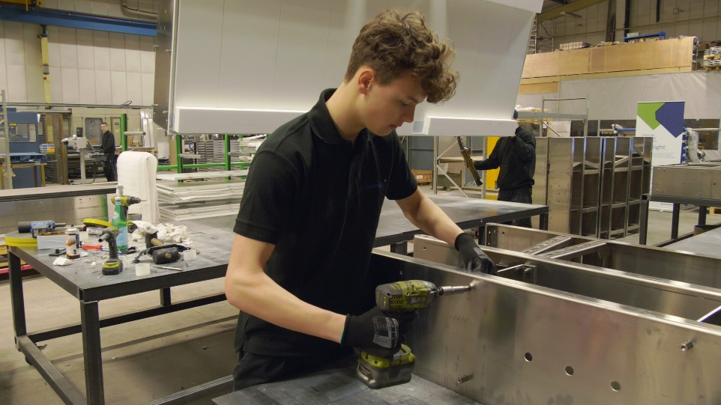
APPRAISAL
You can also write an appraisal about the work the student did for you during the placement, which they could attach to their CV, and could help them apply for work when they’ve finished their course. The provider may give you a form or template for an appraisal. There’s an example below, or you can use one of your own.

REVIEW
The end-of-placement review is where you put on record what the student has achieved during their placement and how well they have performed in their role. You can also talk about such things as their levels of commitment and motivation, how they adapt to new situations, and where their strengths are. You can include pointers for where they might develop their skills and how they can achieve their career ambitions.
The student’s college or school is likely to give you a form for the review. There’s an example below. It will be useful to start completing it before the end-of-placement conversation takes place between you, the student and the college or school, as it will include evidence from several sources that will inform that final review meeting.
Before you complete your review, talk to the student’s supervisor and (if they have one) their mentor. Use what they know about the student from working with them over time. They will already have carried out regular one-to-one reviews with the student and a formal mid-point review – so, there should be information and examples already available. You might also want to talk to the people the student has been working closely with.
The college or school will also record the main points of this conversation. Their record will provide evidence for the decision as to whether the student has completed their placement.
INDUSTRY PLACEMENT - FINAL REVIEW
Student’s name:
Student’s industry placement role:
Provider organisation:
Student’s line manager:
Employer organisation:
Review date:

OVERALL FEEDBACK
Please give feedback on how the student has performed overall. How did the student perform in terms of their behaviour and social skills, and knowledge and technical skills?

STUDENT FEEDBACK
(discussion prompts)
Has the placement given you opportunities to meet your learning goals?
Did you feel supported, and was communication clear and effective?
How could the placement opportunity have been improved?
Has it helped you to decide if this is the type of work that you wish to pursue?

REVIEW AGAINST LEARNING GOALS
(OUTLINED IN THE INDUSTRY PLACEMENT AGREEMENT):
What specific knowledge has the student acquired and/or enhanced during this placement?
What practical skills has the student applied and/or further developed during this placement?
INDUSTRY PLACEMENT – EMPLOYER APPRAISAL
Student’s name:
Student’s industry placement role
Employer organisation:

Student’s role and responsibilities during the placement:
Please describe what they worked on; the team(s) they worked in; and any specific skills they used.
Performance and behaviour
Please comment on the student’s: attendance and reliability; attitude and approach; and, communication and flexibility
Strengths
Please comment on the student’s strengths with regard to, for example: technical skills; communication skills; interpersonal skills; approach to working in isolation, and / or as part of a team; and, approach with customers, if relevant.

Line manager’s name:
Role:
Signature:
Date:

